**Create Node RED Service**

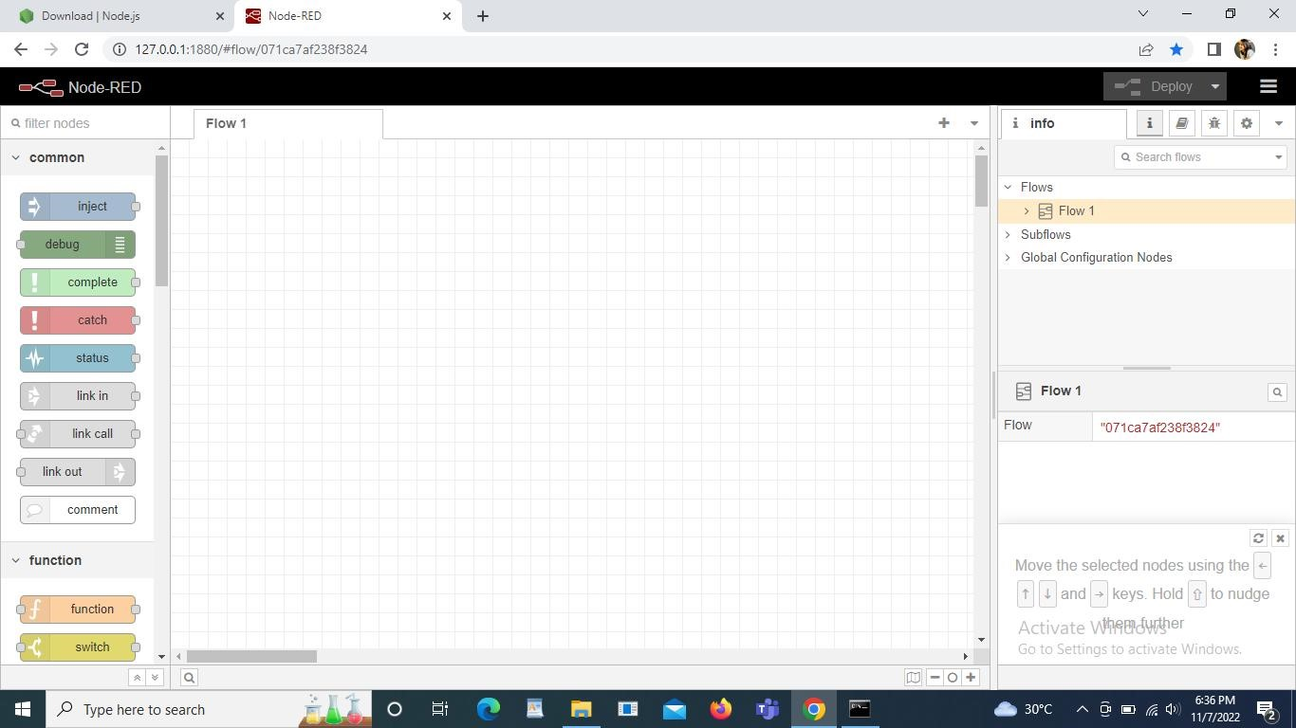

Node RED Created successfully